**RADIX SORT UNRAVELED**

**Introduction:** Radix sort, first conceptualized by Herman Hollerith in 1887, became a practical sorting method for punched cards by 1923. It operates by processing individual digits or characters of numbers or strings from least to most significant, sorting elements based on their radix (the base of the numbering system used). Radix sort handles elements of varying lengths independently and can be more efficient than comparison-based algorithms in certain scenarios, despite its linear time complexity $(O(nw))$ and space complexity $(O(n + k))$. It can also maintain stability, preserving the relative order of elements with equal keys, which is important for specific applications.

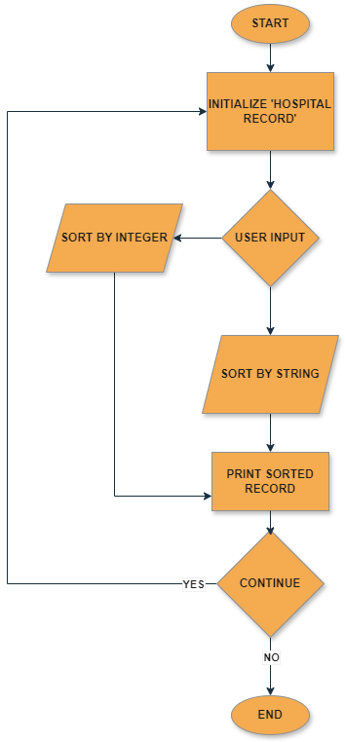**Rational:**  Radix sort is preferred for sorting hospital records due to its efficiency, stability, adaptability, and space complexity. It excels in handling variable-length keys, such as patient IDs and medical codes, by sorting them digit by digit or character by character. Radix sort requires less additional space compared to other sorting algorithms like counting sort and bucket sort, making it more memory efficient, especially in scenarios with large datasets. Its stable sorting nature preserves the relative order of equal elements, which is crucial for maintaining the integrity of medical records. Additionally, radix sort can be easily adapted to sort hospital records based on different criteria, such as patient name, age, admission date, or medical condition. Overall, the combination of these factors makes radix sort a suitable and preferred choice for sorting hospital records efficiently and effectively

**Substitute Use of the Algorithm *-*** Radix sort finds applications beyond sorting hospital records and can be effectively used in various scenarios where keys are represented in a fixed-length format or can be processed digit by digit. One such application is in sorting large volumes of numerical data, particularly in data analysis and scientific computing.